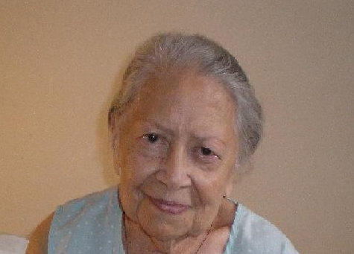

Testimonial to Imelda’s distinguished Ancestry

26/11/2007
19A/177 P Reservoir Rd.
Blacktown, 2148

Dear Imelda, Hija,

I called you yesterday at the eve of your birthday because I knew that your phone would be busy all day. I do not want to send you a card, with stereotyped greetings – the sentiments of a commercial hack, which probably would echo the good wishes in my heart. But instead I have decided to write you a letter which I know you will treasure, not because it is from me but from its contents which I believe you will cherish and live up to- actually I know you already are doing it.
At the age of four my Papa, had two very good friends Jose and Gaudencio Lahoz – your grand uncle and your grandfather. Every day after the Angelus he would jump into his car with me sticking to him like a leech -and this was unfailing in time no matter what the weather was. It was our regular haunt- and these two gentlemen were the epitome’ of correctness, gentility, and kindness. Tata Inciong (your grandpa’s nickname) and Tata Pepe (Jose) never had loud voices, or rough ways. They shared funny stories, chuckled; they exchanged opinions; talked about motors and cars in which all three men had a passion for. Anybody who was well heeled enough to pay the price of a car repair, brought their cars to these two gentlemen who had grease monkeys at their employ and command.
The biggest ad most lucrative of their income came from transportation business- They had buses when not everybody could afford a car. These were used by the Hawaiian Sugar Plantation Co. that recruited Philippine labor for Hawaii. The representative was a certain Mr. McCleod who held your two old forebears in very high regard.
In a small town with a thick residue of Spanish culture and snobbishness they out-snobbed everyone. They did not attend parties, nor give one themselves. They kept to themselves, kept well-ordered homes, brought their children up properly, educated all of their offspring in the best of schools. Above all, my dear girl, (and this should make you proud) not a smiggen of gossip or ill-will ever stained their good name.
In your family (Gaudencio’s) he had a doctor, Manang Puring; Godin, electrical engineer who helped build the Benguet Dam in the Mountain province with your uncle in law Engineer Candelario Versoza; your mother Paz, a lawyer. She was choosy but then came Manong Maning (Manuel Argel, your father) who was a lawyer educated in the U.S. Your grand uncle Pepe had two doctors, one engineer who was general manager of National Power Corporation and an accomplished concert pianist, your Aunt Ising. With so many children, one would have thought that there would be member that would go out of line. There was no one.
Live your life well, my darling girl. All the memory of you, that I have is the smart little girl who was not shy; very outgoing, articulate at a very young age which I think the good Lord gave you in preparation for the career you went for. Your Papa was a judge, you mom a Registrar of Deeds and you, I think have not been left too far behind with the success you have attained. Your Papa & Mama would have been very proud of you hija.
I have had to write you this to make you aware of who you are. I, your “Nana Lourdes” have outlived everyone. I am 90 and would have wanted to be at your birthday parties and tell everyone that Atty Imelda comes from a good and distinguished stock-well bred family clothed in gentility and dignity. Live up to you forebears, my girl. God has blessed you with a good son, a good career and I pray that you would find happiness in love (which has unfortunately escaped you). You deserve to be happy and I hope and pray the good Lord and His blessed Mother will give it to you soon.
This is written to make you know, that I love you, want you to know what and where you are from. I can bet nobody has ever told you what I have written down here. I hope it makes your day, Hija. Happy birthday and I hope you have many more and happier ones.

Your Nana Lourdes (Tanos)

Tel: 02 9831 2674

